Name: Aidil ‘Aqif bin Mohd Pidaus  
Matric Number: 212901  
Assignment: Project - Milestone 2  
Source Code:   
<https://github.com/aidilaqif/SKM3002---Mathematics-for-Multimedia-for-Computing/tree/main/src%20code/Project/Milestone%202>

Sample Output for Linear System with Solution:

Sample Output for Linear System with No Solution:

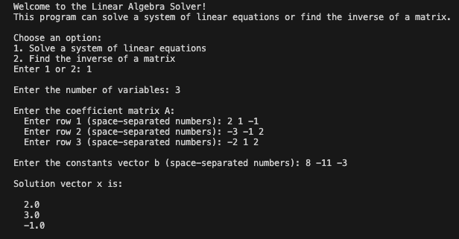

Sample Output for Inverse Matrix:

